Block of the Month for May 2011

SCRAP INSANITY - WHIRLIGIG
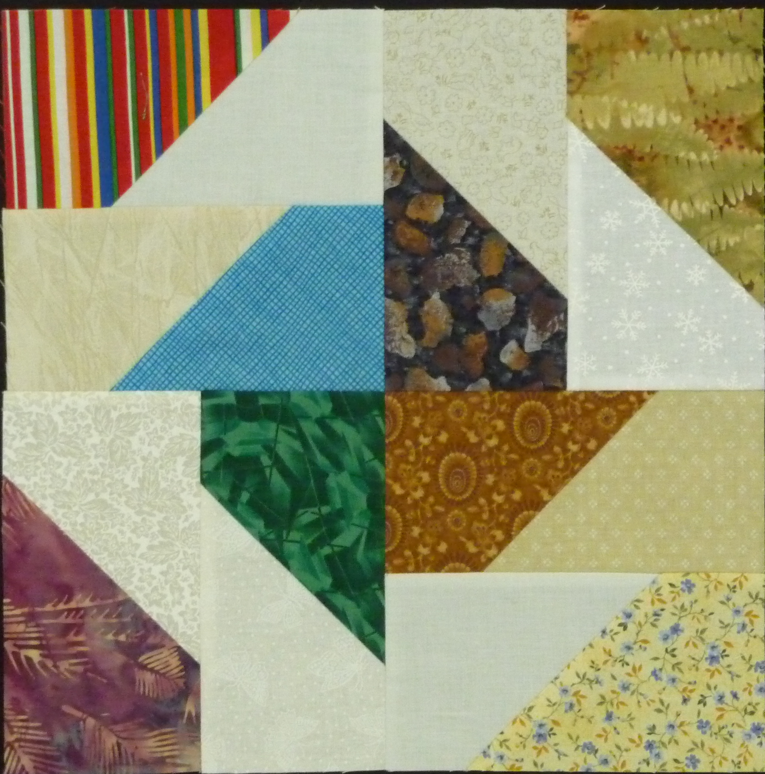
A whirligig is anything that whirls or spins around. Do you remember playing with one when you were a child? Notice how this block spins. When you put them together in a quilt top, you will feel like you are part of the breeze.
There are 16 pieces to this block and it will finish to a 12 1/2” square.

FABRIC:
Background – white or cream. Cut 8 rectangles
3 1/2" x 5”.
Scraps – you will need 8 different medium or dark fabrics. Cut 8 rectangles 3 1/2” x 5”.
ASSEMBLY:
The first seams you sew will determine the direction of the spin. Make sure your units match the pictures at each step!
Make 8 light and dark units. Place a background fabric at a right angle to the scrap fabric right sides together. Stitch across the corner as shown and trim seam to 1/4". Press seam to the scrap.
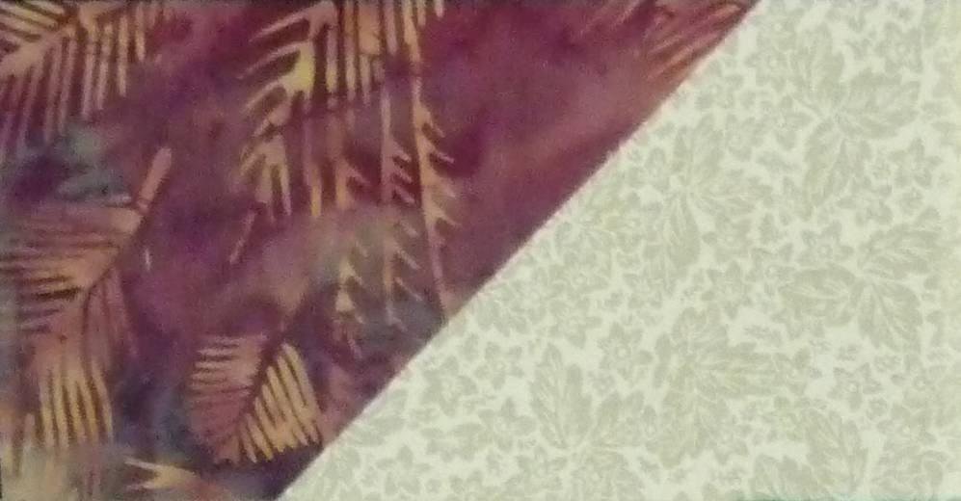
Finished unit will look like this:
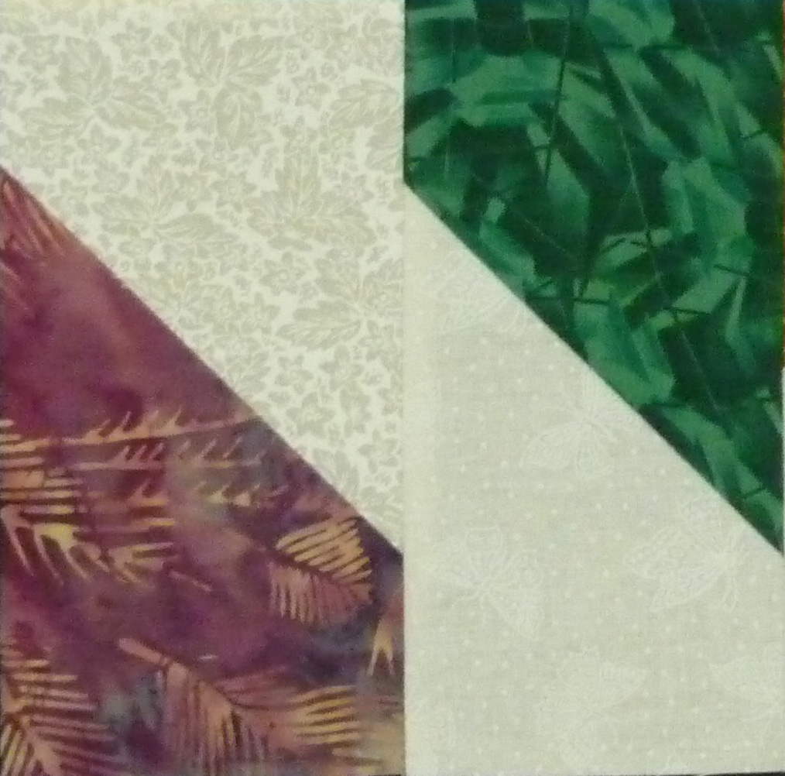
Sew two units together to form one quarter of the block.
Does your unit look exactly like this?
Congratulations, you are almost done! Simply sew four of these units together using the top picture as a guide.
Square the completed block to 12 ½ inches.
Having problems with the block? We are here to help.
Cathe, Darilyn, & Kathy

